

**A**

**Mini-Project Report On**

### SUPERMARKET MANAGEMENT SYSTEM

**In the subject of Mini project**

**Submitted To**

**KIT College Of Engineering (Autonomous), Kolhaapur**

### In Partial Fulfillment of the Requirement for the Degree

**Of**

**Bachelor of Engineering**

**S.Y. B.Tech. CSE**

**Submitted by**

|  |  |
| --- | --- |
| **Name** | **Roll no** |
| **Mangesh Mahesh Gaikwad** | **DCSE 10** |
| **Shrikrushna Chandrakant Gundare** | **DCSE 12** |
| **Omkar Pramod Kulkarni** | **DCSE 16** |
| **Shivaji Laxman Wakshe** | **DCSE 25** |

**(COMPUTER SCIENCE AND ENGINEERING)**

**Guided By**

**Prof. Vinay Prabhavalkar**

**Department Of Computer Science& Engineering KIT’S College of Engineering, Kolhapur.**

**2021-2022**

## CERTIFICATE



This is to certify that Mangesh Gaikwad , Shreekrisna Gundare, Omkar Kulkarni, Shivaji Wakshe successfully completed the Mini-Project entitled **“SUPERMARKET MANAGEMENT SYSTEM”,** in partial fulfilment of the requirement for the Bachelor of Engineering (Computer Science & Engineering) Of KIT’s College of Engineering, Kolhapur in the S.Y. B.Tech. CSE of the academic year 2021-22.

|  |  |
| --- | --- |
| **Project Guide** | **H.O.D. (CSE)** |
| Prof. Vinay Prabhavalkar | Dr. M. S. Kalas |

### Kolhapur Institute of Technology’s College of Engineering, Kolhapur.

**Year2021-2022**

## ACKNOWLEDGEMENT

We would like to express our deep gratitude to Prof. Vinay Prabhavalkar & Dr. M. S. Kalas HOD of CSE for their constant encouragement and belief in us. Their guidance and attention throughout the project work has been of immense help to us. We express our sincere thanks to all the teaching and non-teaching staff and all those who have directly and indirectly helped in marketing project a success.

**Sincerely by,**

|  |  |
| --- | --- |
| **Name** | **Roll no** |
| **Mangesh Mahesh Gaikwad** | **DCSE 10** |
| **Shrikrushna Chandrakant Gundare** | **DCSE 12** |
| **Omkar Pramod Kulkarni** | **DCSE 16** |
| **Shivaji laxman Wakshe** | **DCSE 25** |

## CERTIFICATE

This is to certify that the Mini Project Report entitled **“SUPERMARKET MANAGEMENT SYSTEM”** submitted by Mangesh Gaikwad (DCSE_10), Shrikrushna Gundre(DCSE_12), Omkar Kulkarni(DCSE_16), Shivaji Wakshe(DCSE_25) to KIT’S College of Engineering (Autonomous), Kolhapur, Maharashtra is a record of Bonafide project work carried out by them under my supervision and guidance.

**Supervisor**

**Date:**

## ABSTRACT

**SUPERMARKET MANAGEMENT SYSTEM** The project is on Supermarket Management System is the place where customers come to purchase their daily using products and pay for that. So, there is a need to calculate how many products are sold and to generate the bill for the customer and management system for a admin and employee .In our project we have 2 users. First is the Employee who will enter the products in database. Second one is the administrator who will decide the taxes and commissions on the products and can see the report of any product. Customer come to the employee and give the products which want to perches and employee will calculate and generate the bill for a customer.

## CONTENT

|  |  |  |
| --- | --- | --- |
| **SR NO** | **TITLE** | **PAGE NO** |
| 1. | Chapter 1 – Introduction | 7 |
| 2. | Chapter 2 – System Features | 8 |
| 3. | Chapter 3 - Features | 11 |
| 4. | Chapter 4 – Project Requirements and Model | 12 |
| 5. | Chapter 5 - Modules | 13 |
| 6. | Chapter 6 – System Design | 14 |
| 7. | Chapter 7 – System Testing | 17 |
| 8. | Chapter 8 – System Implementation | 18 |
| 9. | Chapter 9 – Future Enhancements | 21 |
| 10. | Chapter 10 - References | 22 |

**CHAPTER 1**

**INTRODUCTION**

**SUPERMARKET MANAGEMENT SYSTEM** the project is on Supermarket Management System is the place where customers come to purchase their daily using products and pay for that. So, there is a need to calculate how many products are sold and to generate the bill for the customer and management system for an admin and employee .In our project we have 2 users. First is the Employee who will enter the products in database. Second one is the administrator who will decide the taxes and commissions on the products and can see the report of any product. Customer come to the employee and give the products which want to perches and employee will calculate and generate the bill for a customer.

To implement Super-Market Billing System to manage Super-market Records. Being a computer technology student, we had to go into the business department to learn some basic sales and super-market management topic to increase our intellectual understanding on the project and hand it was really tasking.

Building a standard super-market management system was not easy task looking at the problem of existing manual system.

### Scope:

This current system is useful for small supermarkets, mini-stores, and shops which doesn’t require much information

### Objective:

* To make a better system which will make the process easier.
* To properly maintain the records.
* Eliminate the wastage of paper
* To manage the shops properly.
* To save the time of employee as well as customer.

## CHAPTER 2 SYSTEM FEATURES

**Functional Requirements**:

Functional requirements define the fundamental actions that system must perform. The functional requirements for the system are divided into three main categories:

Add new Product, purchase new product, and make bill.

### Modules in our system:

### We will use 5 modules in this project. These are as follows:

### 

### Module 1:

### Login–Id This module is made for the login of users. We know that we have 2 users so login-id is for:

### 1. Administrator

### 2.Employee.

### Module 2:

### Admin can change the product list as per the convineance.

### 1.Add products in the supermarket rack.

### 2. delete product from the rack.

### Module 3:

### Check the Report This module is also for the administrator who can generate or check the report of the product and how many products are sold on particular date or in a period of time.

### Module 4:

### Enter the information about products This module is for data entry operator who will

### 1.Enter the product name and unique id to the customer’s cart.

### 2. make changes in customers cart if required.

### Module-5:

### Calculate the bill This module is for bill calculating operator who will

### 1.Calculate the bill.

### 2.Print it

**Non-Functional Requirements:**

Non-functional requirements define the needs in terms of performance, design constraints, standards compliance, reliability, availability, security, maintainability, and portability.

### Design Constraints.

The Supermarket Management System shall be a stand-alone system running in windows environment.

### Standards Compliance.

There shall be consistency in variable names within the system. The graphical user interface shall have a consistent look and feel.

### Reliability.

Specify the factors required to establish the required reliability of software.

### Availability.

The system shall be available to the owner if he carries necessary files.

### Security.

Market owner will be able to operate to the supermarket management system.

### Portability.

The Supermarket Management System shall run in any Platform.

### Maintainability.

The Supermarket Management System is being developed in C++ is general purpose programming language supporting object-oriented programs and shall be east to maintain.

### Performance Requirements.

Performance requirements define acceptable response times for system functionality. The load time for user interface screens takes no longer than two seconds.

## EXISTING SYSTEM

* + This system totally works manually
  + All details of product are maintained in a file.
  + This system requires a lot of space to keep files, as the number of products increase.
  + Hard to operate and maintain.
  + This system paper based

## PROPOSED SYSTEM

* + - Our system enables the storage of the data.
    - Our proposed system includes proper display of the product information
    - As there is a product list so by using printer it becomes easier and fast to access the bill of any product purchased by a customer.

## Administrator:

**CHAPTER 3**

## Features

* + - **Login:** The administrator will directly login by using the provided password.
    - **Add product:** The administrator can enter basic details of the product such as name, price, unique id, quantity etc.
    - **Display product:** it will display the list of products in the software.
    - **Delete an product:** it will delete the product from the software.
    - **Exit:** By using this system exits from the application and auto logout’s the user.

## Employee:

* + - **Login:** The Employee will directly login by using the provided password.
    - **Display product:** it will display the list of products in the software
    - **Add to cart:** it will help to customer to make the bill and see the price of selected products.
    - **Display cart:** it will display the cart to the customer.
    - **Print bill:** it will print bill on a software.
    - **Exit:** By using this system exits from the application and auto logout’s the user.

## CHAPTER 4

**Project Requirements and Model**

## Software & Hardware Requirement:

* + Windows 7 and above and any linux distro.
  + RAM 2GB
  + Processor Intel core2duo and above.

## SDLC Model

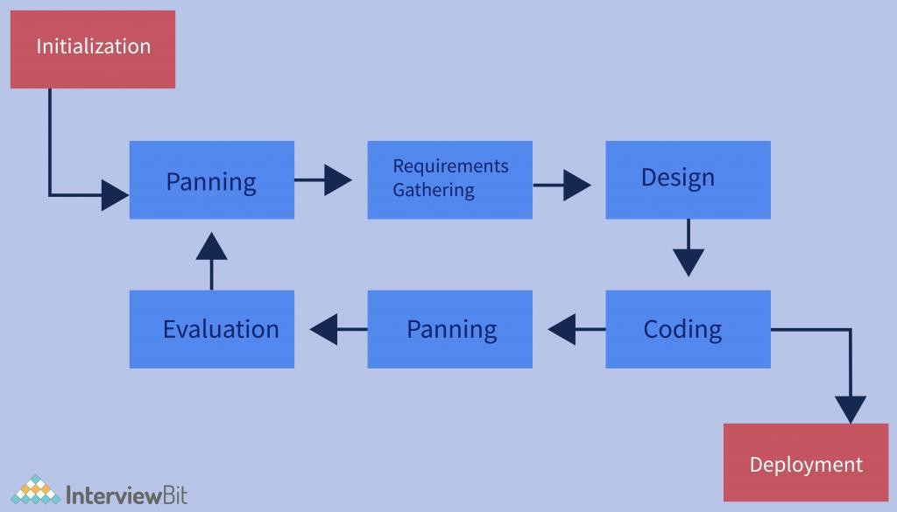

**Fig 4.1 Iterative Model**

# CHAPTER 5

## MODULES

* **Administrator’s module:**

1. Login.
2. Add products.
3. Display products.
4. Delete product.

* **Employee Module:**

1. Login.
2. Add product.
3. Add product to cart.
4. Display cart.
5. Print bill.

# CHAPTER 6

## SYSTEM DESIGN

**USE CASE DIAGRAM:**

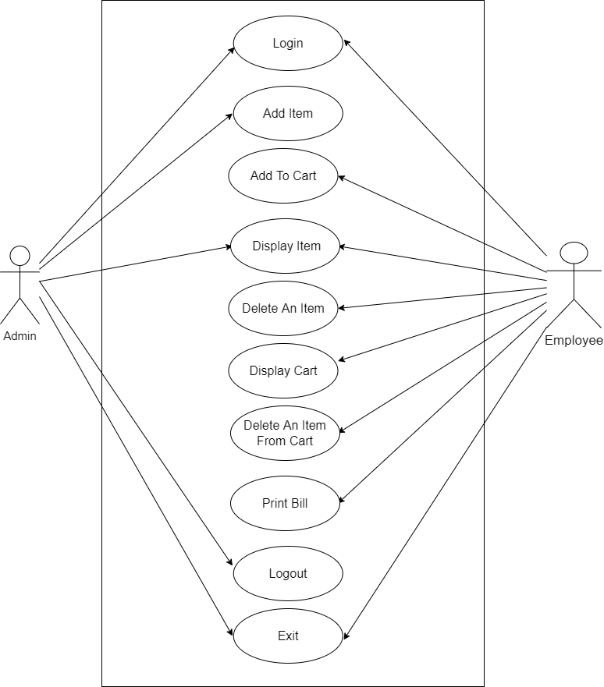

**CLASS DIAGRAM:**

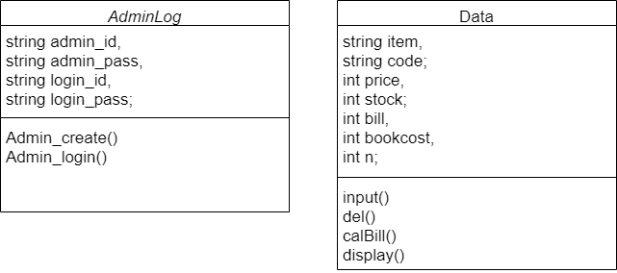

## Entity Relationship Diagram (ER):

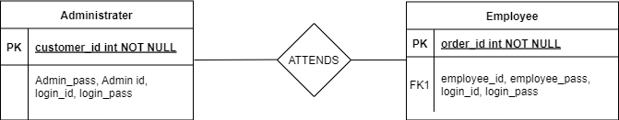

**CHAPTER 7 SYSTEM TESTING**

### Unit Testing

It focuses on the smallest unit of software design. In this, we test an individual unit or group of interrelated units. It is often done by the programmer by using sample input and observing its corresponding outputs.

### Integration Testing

The objective is to take unit tested components and build a program structure that has been dictated by design. Integration testing is testing in which a group of components is combined to produce output.

### System Testing

This software is tested such that it works fine for the different operating systems. It is covered under the black box testing technique. In this, we just focus on the required input and output without focusing on internal working.

**Login Implementation:**

## CHAPTER 8 SYSTEM IMPLEMENTATION

if(login_id.compare(admin_id)==0)

{

if(login_pass.compare(admin_pass)==0)

{

return 1;

}

else

{

cout<<"\nPASSWORD is *invalid*\n";

goto label;

}

}

else

{ cout<<"\nLOGIN ID is *invalid*\n";

goto label;

}}

## CHAPTER 9 FUTURE ENHANCEMENT

Supermarket Management system is vast software and it requires many thing into consideration. Considering the delivery time given to us we have developed the modules which are most important in this system. But we are planning to add some new features in future.

* Maintain the customers data.
* Make software more efficient to the customer .
* Previous bill management.

**CHAPTER 10**

## REFERENCES

**References:**

* + <https://www.tutorialspoint.com/sqlite/sqlite_c_cpp.htm>
  + <https://www.sqlite.org/cintro.html>
  + <https://www.w3schools.com/CPP/default.asp>